Where is the Goddess?
Striving to integrate the Masculine and Feminine
In an Out of Kilter World!
A workshop for women, based on Maureen Murdock’s book,
“The Heroine’s Journey: Women’s Quest for Wholeness.”
We will explore the challenges we face as we strive to answer the questions:
Who am I?
Where am I going?
What is my tribe?
What is my purpose?

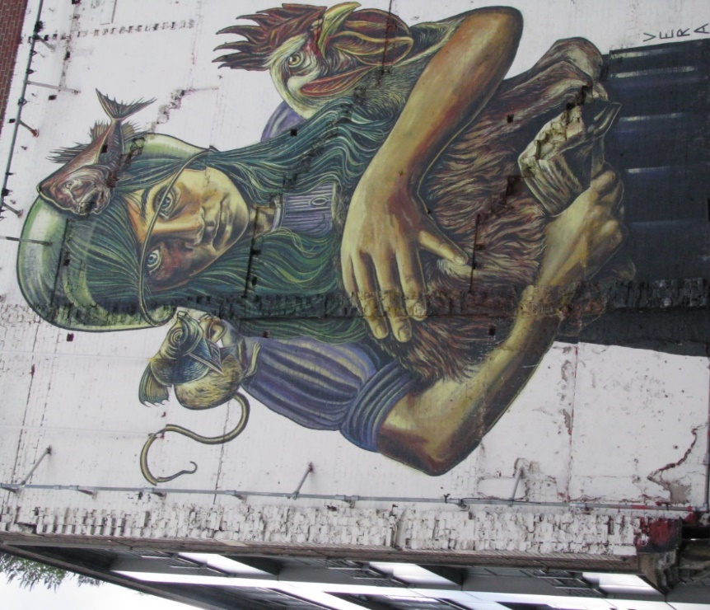

Facilitator: Loraine McDonald
Venue: 22A Sydner Road, N16 7UG
Dates: Sunday the 1st of October and Sunday the 29th of October
Times: 10.00am – 5.00pm
Cost: £120.00
Website: www.lorainemcdonaldcounsellor.co.uk
Email: lorainemcdonald@btinternet.com

